Semi-analytical method to find the solution of a mechanism

Project contributors:
Siddharth Kale
Roll no.: 190003062
Contact no.: 9422187897

Literature review / problem statement:
Problem statement:- To obtain the solution for the given kinematic mechanism with input parameters without analytically solving for it.

Technologies / Softwares used:
- FreeCAD (v0.19)
- Python (v3.9.2)

Though the following analysis can be done on any mechanism, here the methodology is given for Four-bar mechanism.

Methodology / detailed steps:

The input parameters to be taken by user are:
- Crank length
- Coupler length
- Follower length
- Frame length
- Input velocity or Crank velocity
- Input acceleration or Crank acceleration

The crank angle is also the input parameter, but it is not taken by user and we are changing it stepwise to analyze.

Procedure:
- Create the appropriate sketch of configuration diagram for the required mechanism.
- Identify the inputs and the parameters which can be varied in this diagram, and label them accordingly.
- Identify and provide an alias to any constraint which can be temporarily deactivated while setting the initial configuration (to avoid getting error due to invalid configuration in the intermediate state).
- Taking reference of the configuration diagram, make velocity diagram by:
  - giving constraint to input velocity as an arbitrary value (1).
  - applying the directional constraints to velocity vectors.
- Taking reference of the configuration diagram, make acceleration diagram by:
  - giving constraint to input acceleration as an arbitrary value (2).
  - giving constraint to radial accelerations of crank (3), coupler (4) and follower (5), both the magnitude and direction of those components.
  - applying directional constraints to tangential components.
- Take the digital address of the quantities which are to be analyzed (like coupler velocity, follower velocity, coupler tangential acceleration etc.).
- Design, code and run the macro to get the metrics to be analyzed by changing the input angle.
- Create the spreadsheets, collect and store the data and get graphs.

Algorithms:
- Initialize mechanism:
  - Deactivate the temporary constraint.
  - For each parameter (in this case, lengths of links):
    - Set appropriate constraint.
  - Activate temporary constraint.
- Show animation:
  - Initialize input angle and number of revolutions to 0.
  - While required number of revolutions are not completed:
    - Increment the input angle by some value.
    - If input angle is 360:
      - Increment the revolutions completed.
- Analyze mechanism:
  - Clear the previous data.
  - Initialize input angle to 0 and step size to appropriate value to be incremented in each step.
  - Set constraints for input velocity and input acceleration.
  - While input angle < 360:
    - Find the coupler angle, follower angle and transmission angle from configuration diagram.
    - Find the co-ordinates of the mid-point of the coupler.
    - Put all these values in spreadsheet.
    - Find the magnitude of coupler and follower velocity from the velocity diagram.
    - Find the direction of the angular velocities of the coupler and follower by considering their velocities with respect to their positioning, and magnitude.
    - Put all these values in spreadsheet.
    - Set the constraints for the magnitude of radial accelerations of crank, coupler and follower.
    - Find the magnitude of total coupler and follower acceleration from the acceleration diagram.
    - Find the direction of the angular accelerations of the coupler and follower by considering their tangential accelerations with respect to their positioning, and magnitude.
    - Put all these values in spreadsheet.
    - Increase input angle by step size.
- Show plots:
  - Initialize empty array for each metric to be plotted.
  - Make the array of input angle by taking multiple full cycles.
  - For each cycle:
    - Append values of the metric in the corresponding array.
  - Plot the graph of the metric against input angle.

Notes:
- Check if the configuration diagrams are fully constrained to guarantee unique output.
- Make separate sketches for configuration diagram, velocity diagram and acceleration diagram to avoid crashes when setting constraints.
- If using index to obtain geometric components from the sketch (velocity or acceleration diagram), keep them consistent in the other configurations (such as open and cross) to obtain errorless data.
- While measuring angles, consider direction of the vectors, to get correct anti-clockwise readings.
- Show plots for multiple rotations to get better understanding from the plots.

Results and discussion with plots and figures:
The normal configuration diagram is just the two-dimensional representation of the mechanism. The velocity diagram and the acceleration diagram are the sketches used to obtain the metrics. While animating the mechanism, the metrics are calculated in the background without explicitly providing the mathematical equations for the same.

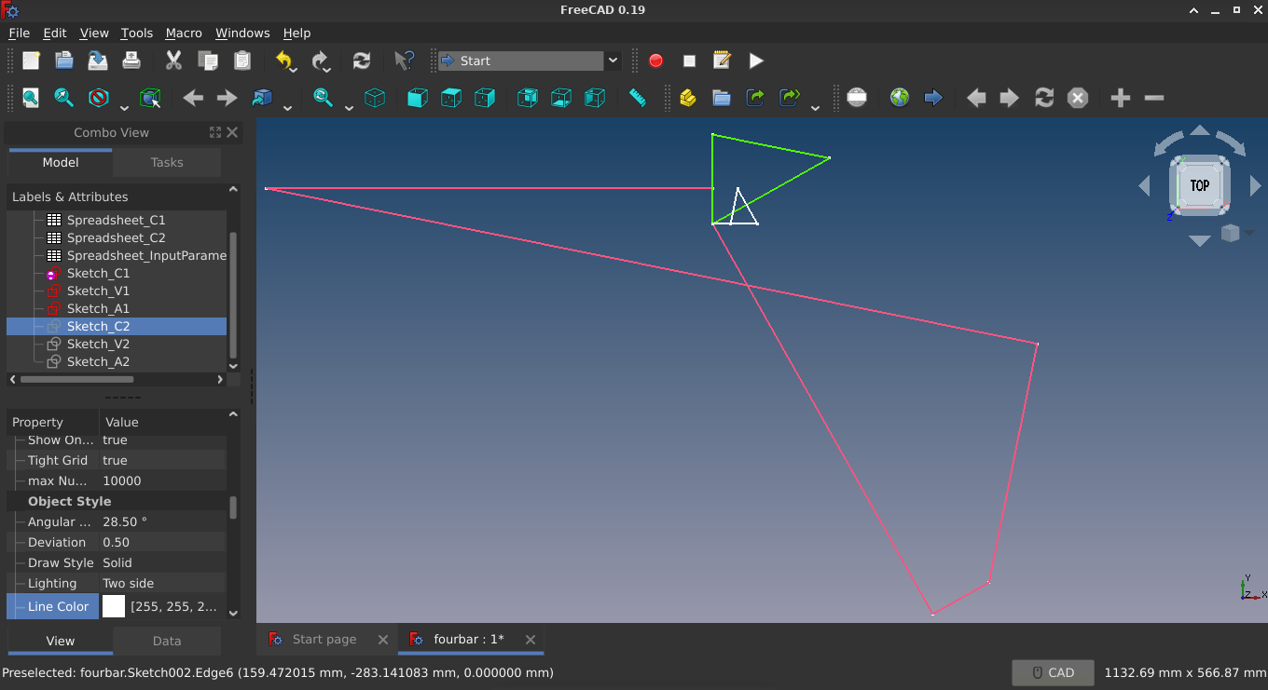Illustration 1: Configuration, velocity and acceleration diagram

The maximum and minimum values for the metric obtained by differentiating an equation can also be obtained from analyzing the graphs. Some other trends, like slope, range, point with maximum acceleration, which are difficult to visualize from the equation, can be easily spotted from the animation and the graphs.
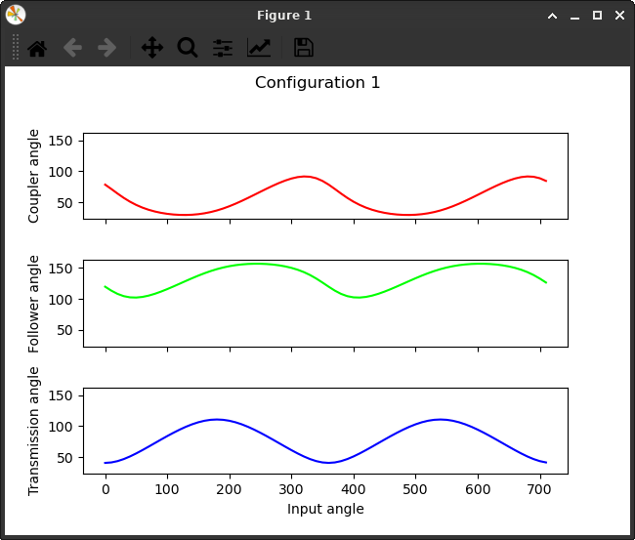Figure 1: Configuration angles vs input angle
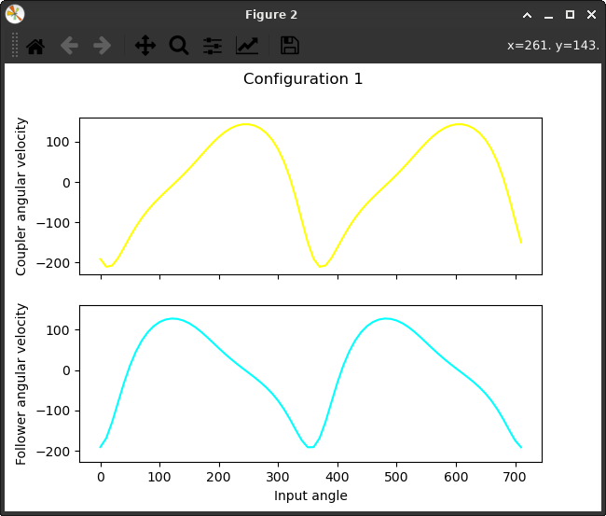Figure 2: Angular velocities vs. input angle
These graphs can be used to determine the following:
- The coupler angle is never exceeding 100^{O} and the follower angle is in the range of 100^{O} to 150^{O}.
- The maximum angular velocities for both coupler and follower are around 200 rad/s in magnitude.
- The angular velocities for both coupler and follower are negative (clockwise) for greater range of input angle.
- The coupler angular velocity is maximum in anti-clockwise direction for 280^{O} input angle and the follower angle angular velocity is maximum in anti-clockwise direction for 120^{O} input angle.

Conclusions / findings / design values / parameters:
Using this technique, the mechanism can be analyzed without obtaining and solving complex mathematical equations. This technique does not involve complex programming or mathematical skills. Also, it involves one time setup, and we can control multiple parameters without changing the setup.
This method can be efficient, where:
- There are certain parameters to be optimized.
- The maximum velocity or acceleration of some link is to be found.
- The analysis is to be done on the mechanism by changing a certain set of parameters.
The configuration diagram at some arbitrary points does not help in understanding the mechanism, but the animation makes the picture clear in the mind.
The sketches, when seen all together, does not explain anything, but it becomes easy to visualize and check if the diagrams are correct.

References: (if any)
- https://wiki.freecadweb.org/Power_users_hub
- https://wiki.freecadweb.org/Sketcher_Workbench
- https://wiki.freecadweb.org/FreeCAD_vector_math_library

Code developed:
import time
import math
import DraftVecUtils
import matplotlib.pyplot as plt
import numpy as np

APP=App.getDocument("fourbar")
GUI=Gui.getDocument("fourbar")
ROTATIONS=2

def obj_label(label):
return APP.getObjectsByLabel(label)[0];

def get_edge_vector(edge):
return edge.EndPoint.sub(edge.StartPoint)

def get_edge_midpoint(edge):
return edge.EndPoint.add(edge.StartPoint).multiply(0.5)

def get_ccwangle(v1,v2,always_positive=False): #counter clockwise
angle=DraftVecUtils.angle(v1,v2)
if always_positive and angle<0:
return angle+2*math.pi
return angle

def set_mechanism(sktch,sprdsheet):
i=1
for j in sktch:
j.toggleActive(j.getIndexByName("TmpConstraint"))
while sprdsheet.get('A'+str(i))!="End":
for j in sktch:
j.setDatum( j.getIndexByName(sprdsheet.get('A'+str(i))) , App.Units.Quantity(sprdsheet.get('B'+str(i))) )
i=i+1
for j in sktch:
j.toggleActive(j.getIndexByName("TmpConstraint"))
return

def show_animation(revs,sktch,sprdsheet):
GUI.setEdit(sktch.ViewObject)
angle=0
revolutions=0
while revolutions<revs:
time.sleep(0.001)
angle+=5
sktch.setDatum(sktch.getIndexByName("InputAngle"),App.Units.Quantity(str(angle)+" deg"))
Gui.updateGui()
if angle == 360:
angle=0
revolutions+=1
print(str(revolutions)+" revolution/s completed")
sktch.setDatum(sktch.getIndexByName("InputAngle"),App.Units.Quantity('0 deg'))
APP.recompute()
GUI.resetEdit()
Gui.updateGui()
return

def analyze_mechanism(steps,sprdsheet,configD,velD,accD,sprdsheet_input):
sprdsheet.clear('B4:Z5000')
angle=0
step=360/steps

configD.setDatum(configD.getIndexByName("InputAngle"),App.Units.Quantity('0 deg'))
velD.setDatum(velD.getIndexByName("InputVelocity"),App.Units.Quantity(sprdsheet_input.get("E1")))
accD.setDatum(accD.getIndexByName("InputAcceleration"),App.Units.Quantity(sprdsheet_input.get("E2")))
APP.recompute()
bars=configD.Geometry
lCrank=bars[0].length()
lCoupler=bars[1].length()
lFollower=bars[2].length()
while angle<360:
APP.recompute()
bars=configD.Geometry
vels=velD.Geometry
accs=accD.Geometry

coupler_angle=math.degrees(get_ccwangle(get_edge_vector(bars[3]).multiply(-1),get_edge_vector(bars[1]),True))
follower_angle=math.degrees(get_ccwangle(get_edge_vector(bars[3]),get_edge_vector(bars[2]),True))
transmission_angle=math.degrees(get_ccwangle(get_edge_vector(bars[1]),get_edge_vector(bars[2]).multiply(-1),True))
sprdsheet.set('B'+str(int(4+angle/step)),"= "+str(angle)+" deg")
sprdsheet.set('C'+str(int(4+angle/step)),"= "+str(coupler_angle)+" deg")
sprdsheet.set('D'+str(int(4+angle/step)),"= "+str(follower_angle)+" deg")
sprdsheet.set('E'+str(int(4+angle/step)),"= "+str(transmission_angle)+" deg")
sprdsheet.set('G'+str(int(4+angle/step)),"= "+str(bars[0].EndPoint.x)+" mm")
sprdsheet.set('H'+str(int(4+angle/step)),"= "+str(bars[0].EndPoint.y)+" mm")
sprdsheet.set('I'+str(int(4+angle/step)),"= "+str(bars[2].StartPoint.x)+" mm")
sprdsheet.set('J'+str(int(4+angle/step)),"= "+str(bars[2].StartPoint.y)+" mm")

vCrank=vels[0].length()
vCoupler=vels[1].length()
vFollower=vels[2].length()
sprdsheet.set('L'+str(int(4+angle/step)),"= "+str(vCoupler)+" mm/s")
sprdsheet.set('M'+str(int(4+angle/step)),"= "+str(vFollower)+" mm/s")
dirVC = 1 if get_ccwangle(get_edge_vector(bars[1]),get_edge_vector(vels[1]))>0 else -1
dirVF = 1 if get_ccwangle(get_edge_vector(bars[2]),get_edge_vector(vels[2]))>0 else -1
sprdsheet.set('N'+str(int(4+angle/step)),"= "+str(dirVC * vCoupler / lCoupler)+" rad/s")
sprdsheet.set('O'+str(int(4+angle/step)),"= "+str(dirVF * vFollower / lFollower)+" rad/s")

accD.setDatum(accD.getIndexByName("RadialCrank"),App.Units.Quantity(str(vCrank * vCrank / lCrank)+" mm"))
accD.setDatum(accD.getIndexByName("RadialCoupler"),App.Units.Quantity(str(vCoupler * vCoupler / lCoupler)+" mm"))
accD.setDatum(accD.getIndexByName("RadialFollower"),App.Units.Quantity(str(vFollower * vFollower / lFollower)+" mm"))
APP.recompute()

accs=accD.Geometry
sprdsheet.set('Q'+str(int(4+angle/step)),"= "+str(math.sqrt(accs[0].length()**2 + accs[1].length()**2))+" mm/s^2")
sprdsheet.set('R'+str(int(4+angle/step)),"= "+str(math.sqrt(accs[2].length()**2 + accs[3].length()**2))+" mm/s^2")
sprdsheet.set('S'+str(int(4+angle/step)),"= "+str(math.sqrt(accs[4].length()**2 + accs[5].length()**2))+" mm/s^2")
dirAC = 1 if get_ccwangle(get_edge_vector(bars[1]),get_edge_vector(accs[2]))>0 else -1
dirAF = 1 if get_ccwangle(get_edge_vector(bars[2]),get_edge_vector(accs[4]))>0 else -1
sprdsheet.set('T'+str(int(4+angle/step)),"= "+str(dirAC * accs[2].length() / lCoupler)+" rad/s^2")
sprdsheet.set('U'+str(int(4+angle/step)),"= "+str(dirAF * accs[4].length() / lFollower)+" rad/s^2")
angle+=step

configD.setDatum(configD.getIndexByName("InputAngle"),App.Units.Quantity(str(angle)+' deg'))

configD.setDatum(configD.getIndexByName("InputAngle"),App.Units.Quantity('0 deg'))
APP.recompute()
print("Spreadsheet updated.")
return

def show_plots(sprdsheet):
for i in sprdsheet:
inputA=[]
couplerA=[]
followerA=[]
transmissionA=[]
couplerVwrtcrank=[]
followerV=[]
couplerAccwrtcrank=[]
followerAcc=[]
row=4
while i.getContents('B'+str(row))!="":
inputA.append(float(i.get('B'+str(row)).toStr().split()[0]))
inputA.append(360+inputA[len(inputA)-1])
couplerA.append(float(i.get('C'+str(row)).toStr().split()[0]))
followerA.append(float(i.get('D'+str(row)).toStr().split()[0]))
transmissionA.append(float(i.get('E'+str(row)).toStr().split()[0]))
couplerVwrtcrank.append(float(i.get('N'+str(row)).toStr().split()[0]))
followerV.append(float(i.get('O'+str(row)).toStr().split()[0]))
couplerAccwrtcrank.append(float(i.get('S'+str(row)).toStr().split()[0]))
followerAcc.append(float(i.get('T'+str(row)).toStr().split()[0]))
row=row+1

inputA.sort()
couplerA.extend(couplerA)
followerA.extend(followerA)
transmissionA.extend(transmissionA)
couplerVwrtcrank.extend(couplerVwrtcrank)
followerV.extend(followerV)
couplerAccwrtcrank.extend(couplerAccwrtcrank)
followerAcc.extend(followerAcc)

fig, axs = plt.subplots(3, sharex=True, sharey=True)
if i.Label.find("C1") != -1:
fig.suptitle("Configuration 1")
if i.Label.find("C2") != -1:
fig.suptitle("Configuration 2")
axs[2].set_xlabel('Input angle')
axs[0].set_ylabel('Coupler angle')
axs[0].set_aspect(1)
axs[1].set_ylabel('Follower angle')
axs[1].set_aspect(1)
axs[2].set_ylabel('Transmission angle')
axs[2].set_aspect(1)
axs[0].plot(np.array(inputA),np.array(couplerA),color = (1,0,0))
axs[1].plot(np.array(inputA),np.array(followerA),color = (0,1,0))
axs[2].plot(np.array(inputA),np.array(transmissionA),color = (0,0,1))

fig.show()

fig, axs = plt.subplots(2, sharex=True, sharey=True)
if i.Label.find("C1") != -1:
fig.suptitle("Configuration 1")
if i.Label.find("C2") != -1:
fig.suptitle("Configuration 2")
axs[1].set_xlabel('Input angle')
axs[0].set_ylabel('Coupler angular velocity')
axs[1].set_ylabel('Follower angular velocity')

axs[0].plot(np.array(inputA),np.array(couplerVwrtcrank),color = (1,1,0))
axs[1].plot(np.array(inputA),np.array(followerV),color = (0,1,1))

fig.show()

fig, axs = plt.subplots(2, sharex=True, sharey=True)
if i.Label.find("C1") != -1:
fig.suptitle("Configuration 1")
if i.Label.find("C2") != -1:
fig.suptitle("Configuration 2")
axs[1].set_xlabel('Input angle')
axs[0].set_ylabel('Coupler angular acceleration')
axs[1].set_ylabel('Follower angular acceleration')

axs[0].plot(np.array(inputA),np.array(couplerAccwrtcrank),color = (1,0.5,0.5))
axs[1].plot(np.array(inputA),np.array(followerAcc),color = (0.5,0.5,1))

fig.show()

return

print("Started...")

def debug(sktchs):
for i in sktchs:
if not i.FullyConstrained:
raise RuntimeError(i.Label+" is not fully constrained.")
return

debug([obj_label("Sketch_C1"),obj_label("Sketch_C2")])
set_mechanism([obj_label("Sketch_C2"),obj_label("Sketch_C1")],obj_label("Spreadsheet_InputParameters"))
show_animation(ROTATIONS,obj_label("Sketch_C2"),obj_label("Spreadsheet_InputParameters"))
show_animation(ROTATIONS,obj_label("Sketch_C1"),obj_label("Spreadsheet_InputParameters"))
analyze_mechanism(36,obj_label("Spreadsheet_C1"),obj_label("Sketch_C1"),obj_label("Sketch_V1"),obj_label("Sketch_A1"),obj_label("Spreadsheet_InputParameters"))
analyze_mechanism(36,obj_label("Spreadsheet_C2"),obj_label("Sketch_C2"),obj_label("Sketch_V2"),obj_label("Sketch_A2"),obj_label("Spreadsheet_InputParameters"))
show_plots([obj_label("Spreadsheet_C1"),obj_label("Spreadsheet_C2")])

# exec(open("/home/user/Documents/FreeCAD/Macro/rotate_4bar.FCMacro").read())

